 | Academic International Journal of Social Sciences and Humanities  ISSN: 2984-7729  Aca. Int. J. Soc. Sci. H. year; volume (issue) pages  Journal homepage: http://www.aipublishers.org/aijssh | 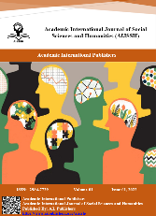

Title Capital, Each Word Font 14 Times New Roman, Centre
First Author¹, Second Author², Third Author³
Author/s Affiliation
Corresponding Author Email: official email@affiliation.org
Abstract:
Article Info.
Article history:
Receive 2 July 2025
Revised 26 July 2025
Accepted 7 September 2025
Published 11 October 2025
Keywords:
3-6 keywords times new roman 9
How to cite:
Author/s (year). title. Aca. Intl. J. Soc. Sci. H. volume (issue) pages.
https://doi.org/10.59675/article code
Copyright:
© year A.I. Publishers.
All Rights Reserved.
Times New Roman 12 line spacing 1.0, justify

Introduction
Times New Roman 12 line spacing 1.0, justify. Reference (Abu Daaif, 2016), (Smith & Johnson, 2020), (Al-Naimi et al., 2021)

Methodology
Times New Roman 12 line spacing 1.0, justify. Reference (Abu Daaif, 2016), (Smith & Johnson, 2020), (Al-Naimi et al., 2021).

Results
Times New Roman 12 line spacing 1.0, justify. Reference (Abu Daaif, 2016), (Smith & Johnson, 2020), (Al-Naimi et al., 2021).

Table 1: table title bold, Times New Roman 10
Response | Percentage | Number of Respondents
Strongly Agree | 50.5% | 47
Agree | 31.2% | 29
Neutral | 6.5% | 6
Disagree | 6.5% | 6
Strongly Disagree | 5.4% | 5

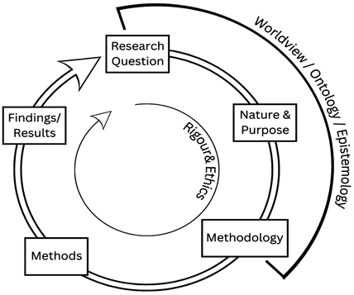
Figure 1: Figure title bold, Times New Roman 10

Discussion
Times New Roman 12 line spacing 1.0, justify. Reference (Abu Daaif, 2016), (Smith & Johnson, 2020), (Al-Naimi et al., 2021).

Conclusion

Times New Roman 12 line spacing 1.0, justify. Reference (Abu Daaif, 2016), (Smith & Johnson, 2020), (Al-Naimi et al., 2021).

Recommendations

Times New Roman 12 line spacing 1.0, justify. Reference (Abu Daaif, 2016), (Smith & Johnson, 2020), (Al-Naimi et al., 2021).

References
- 1. Journal Article
- Format:
- Author, A. A., & Author, B. B. (Year). Title of the article. Title of Journal, volume number (issue number), page range. https://doi.org/xxxxx
- Example:
- Smith, J. T., & Ahmed, R. K. (2022). Innovation in small business management. Journal of Entrepreneurship Studies, 15(2), 113–128. https://doi.org/10.1234/jes.2022.45

- 2. Journal Article with More Than 20 Authors
- Format:
- List first 19 authors → add … → add final author.
- Example:
- Al-Najjar, S., Musa, R., Lee, P., … Khan, M. (2022). Global migration trends. International Review of Sociology, 18(1), 45–60.

- 3. Book
- Format:
- Author, A. A. (Year). Title of the book. Publisher.
- Example:
- Abu Daaif, M. A. (2016). Entrepreneurship: Creativity, innovation, and management. Al-Qalam Publishing.

- 4. Edited Book
- Format:
- Editor, A. A. (Ed.). (Year). Title of the book. Publisher.
- Example:
- Brown, K. L. (Ed.). (2020). Social theory in the 21st century. Cambridge Press.

- 5. Chapter in an Edited Book
- Format:
- Author, A. A. (Year). Chapter title. In A. Editor & B. Editor (Eds.), Book title (pp. xx–xx). Publisher.
- Example:
- Yousef, H. (2021). Cognitive development in adolescence. In L. Carter (Ed.), Handbook of developmental psychology (pp. 55–72). Academic Press.

- 6. Website
- Format:
- Author or Organisation. (Year, Month, Day). Title of page. Site name. URL
- Example:
- World Health Organisation. (10 May 2023). Mental health: Strengthening our response. WHO. https://www.who.int/mental-health/

- 7. Online News Article
- Format:
- Author, A. A. (Year, Month Day). Title of article. Newspaper Name. URL
- Example:
- Khalid, A. (2024, March 5). Economic reforms in the Middle East. The Guardian. https://www.theguardian.com/economy

- 8. Thesis or Dissertation
- Format:
- Author, A. A. (Year). Title of thesis or dissertation (Publication No. xxxx) [master’s thesis/Doctoral dissertation, University Name]. Database.
- Example:
- Rahman, T. M. (2020). Public policy and social inequality [Doctoral dissertation, University of Jordan]. ProQuest Dissertations Publishing.

- 9. Conference Paper
- Format:
- Author, A. A. (Year). Title of paper. In A. Editor (Ed.), Conference proceedings title (pp. xx–xx). Publisher.
- Example:
- Salem, R. (2021). Social media use in education. In K. Brown (Ed.), Proceedings of the International Conference on Education (pp. 89–94). Springer.

